Human Study

School of Rehabilitation Sciences

Basic and Advanced

Blended Learning Education

**Student Portfolio**

Modules I-IV

ISPO Associate Prosthetist/Orthotist

**Andrii Sadovnik**

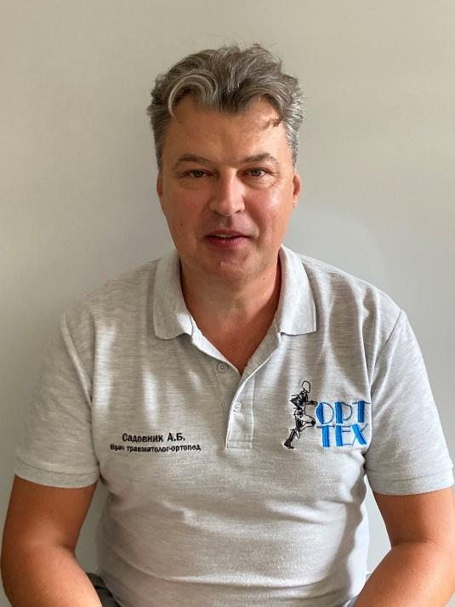

# Portfolio content

**Portfolio content 2**

**Curriculum Vitae 3**

**Lower Extremity Prosthetics 5**

**Lower Extremity Orthotics 7**

**Upper Extremity Prosthetics 9**

**Upper Extremity Orthotics & Trunk Orthotics 11**

**Grades Obtained During the Education 13**

# Curriculum Vitae

|  |  |  |  |  |  |
| --- | --- | --- | --- | --- | --- |
|  |  |  | | | |
|  |
|  | |  | | | |
|  | |  | | | |
| **Personal information** | |  | | | |
| First name and last name | | Andrii Sadovnik | | | |
| Address | | Kyiv, Ukraine | | | |
| Telephone(s) | |  | |  |  |
| Mobile phone number | | +380503683622 | | | |
| E-mail | | asadovnik@ukr.net | | | |
|  | |  | | | |
| Nationality | | Ukrainian | | | |
|  | |  | | | |
| Date of birth | | February 6th, 1973 | | | |
|  | |  | | | |
|  | |  | | | |
|  | |  | | | |
| **Work experience** | |  | | | |
|  | |  | | | |
|  | |  | | | |
|  | |  | | | |
| Dates | |  | | | |
| Occupation or position held | | Deputy Director for Medicine | | | |
| Main activities and responsibilities | | Medical practice, training of employees, P&O device production | | | |
| Name and address of employer | | P&O Rehabilitation Center Orttekh, Zaporizhzhia, Ukraine | | | |
| Type of business or sector | | Private P&O workshop | | | |
|  | |  | | | |
| **Education and training** | |  | | | |
|  | |  | | | |
| Dates | |  | | | |
| School | | Donetsk State Medical University | | | |
| Degree | | Specialist in Orthopedic Traumatology, Highest Category | | | |
| Name and type of organisation providing the additional courses | | Many courses in P&O from Ottobock and from Ukrainian Research Institute for Prosthetics and Rehabilitation | | | |
|  | |  | | | |
|  | |  | | | |
| **Personal skills and competences** | |  | | | |
|  | |  | | | |
| Mother tongue(s) | | **Russian, Ukrainian** | | | |
|  | |  | | | |
| Other language(s) | |  | | | |
| Self-assessment | |  |  | | |
| **English** | |  |  | | |
|  | |  | | | |
|  | |  | | | |
| Technical skills and competences | | Individual production of lower limb prostheses, lower limb orthoses, corsets | | | |
|  | |  | | | |
| Computer skills and competences | | MS Office and internet research skills | | | |
|  | |  | | | |
|  | |  | | | |

# Lower Extremity Prosthetics

Usage of DLE platform

This table shows student Andrii Sadovnik’s online platform activity in comparison with his classmates.

Case Presentations[1]

|  |  |
| --- | --- |
| *Transtibial Prosthesis Case Presentation* | *Transfemoral Prosthesis Case Presentation* |
|  |  |

Practical activities – workshops and exams

*Lower Extremity Prosthetics exam – November 2020 – Kharkiv, Ukraine*

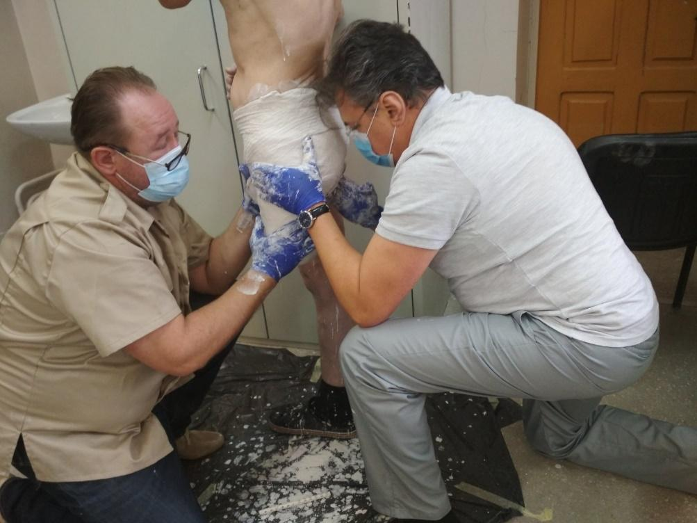

*Exam, Kharkiv, Ukraine – November 2020; Casting*

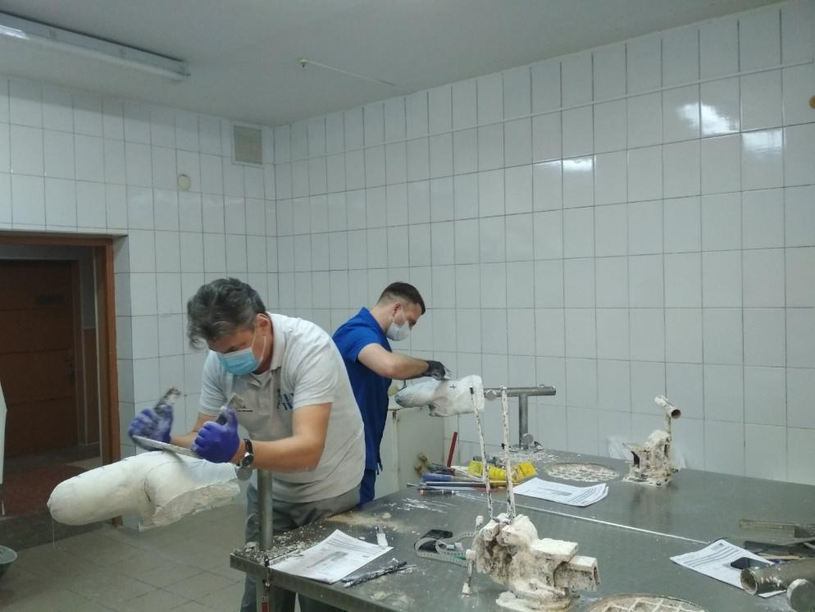

*Exam, Kharkiv, Ukraine – November 2020; Model Rectification*

# Lower Extremity Orthotics

Usage of DLE platform

This table shows student Andrii Sadovnik’s online platform activity compared to his classmates.

Case Presentations[2]

|  |  |
| --- | --- |
| *AFO Case Presentation* | *KAFO Case Presentation* |
|  |  |

Practical activities – workshops and exams

*Lower Extremity Orthotics –March 2021 – Kharkiv, Ukraine*

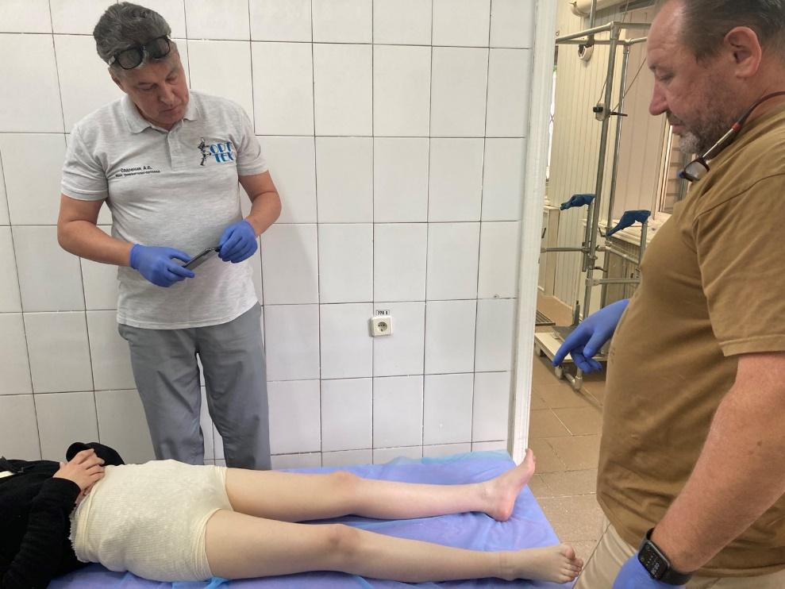

*Exam, Kharkiv, Ukraine – March, 2021; Patient Assessment*

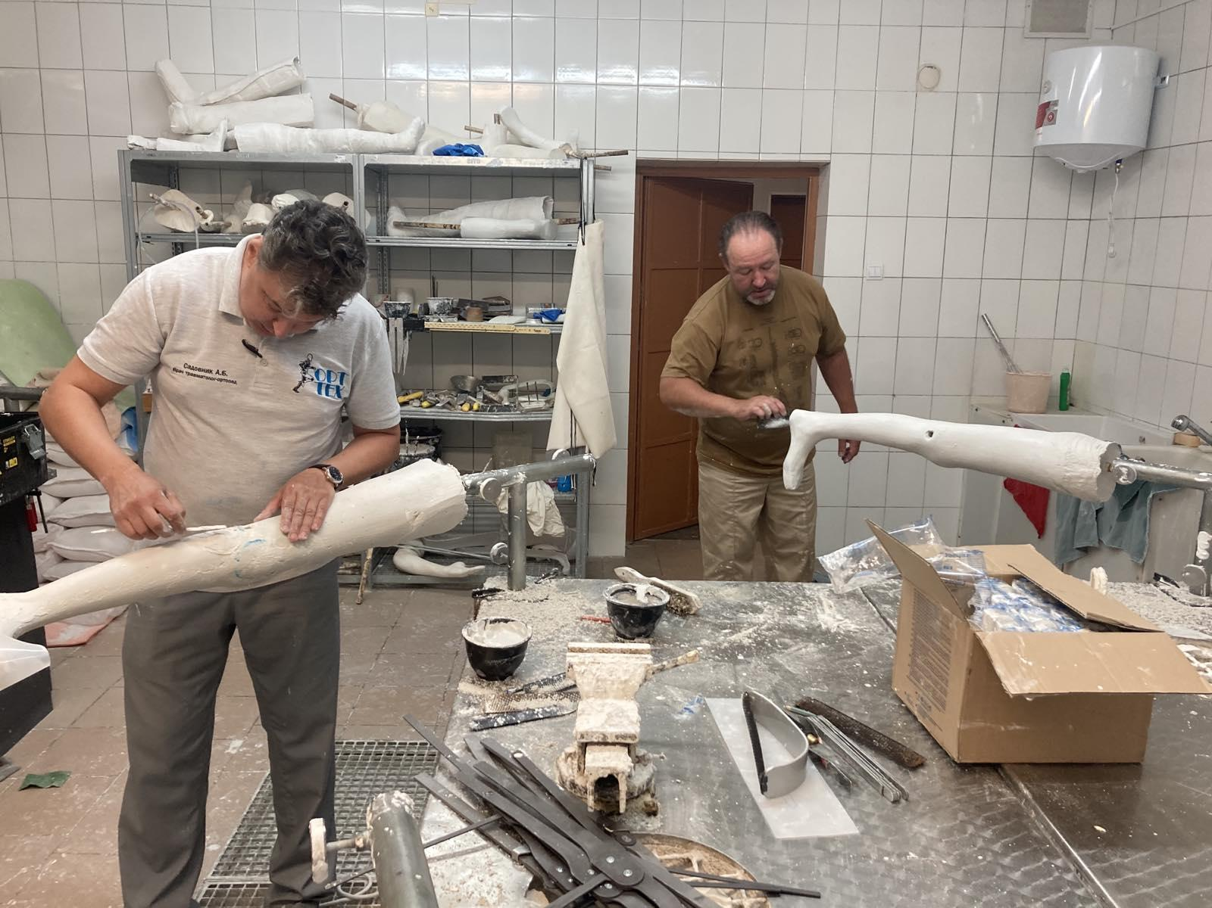

*Exam, Kharkiv, Ukraine – March, 2021; Model Rectification*

# Upper Extremity Prosthetics

Usage of DLE platform

This table shows student Andrii Sadovnik’s online platform activity compared to his classmates.

Case Presentations[3]

|  |
| --- |
| *TR Case Presentation* |
|  |

Practical activities – workshops and exams

*Upper Extremity Prosthetics –August, September 2021– Kharkiv, Ukraine*

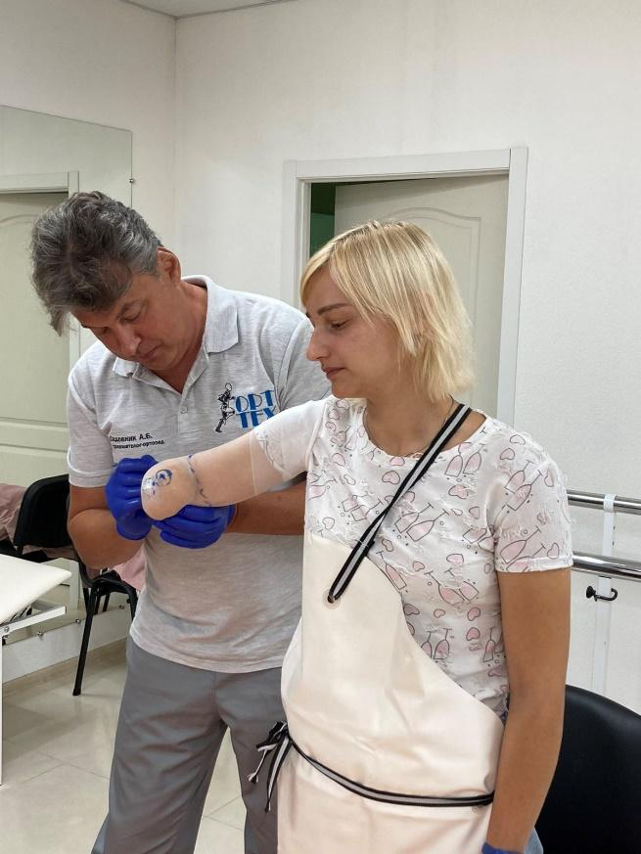

*Workshop, Zaporizhzhia, Ukraine – August 2021; Taking measurements*

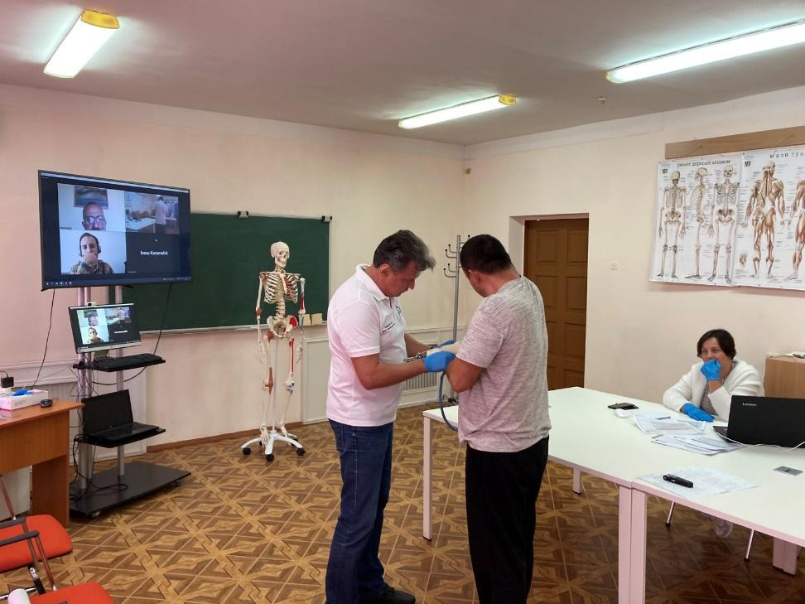

*Exam, Kharkiv, Ukraine – September 2021*

# Upper Extremity Orthotics & Trunk Orthotics

Usage of DLE platform

This table shows student Andrii Sadovnik’s online platform activity compared to his classmates.

Case Presentations[4]

|  |  |
| --- | --- |
| *EWHO Case Presentation* | *TO Assigned Topic Presentation* |
|  |  |

Practical activities – workshops and exams

*Upper Extremity Orthotics & Trunk Orthotics –September 2021 – Kharkiv, Ukraine*

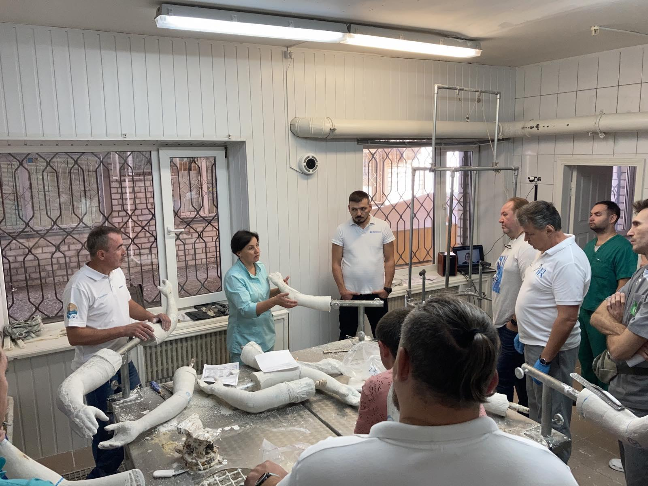

*ULO Workshop, Kharkiv, Ukraine – September 2021; Model Rectification*

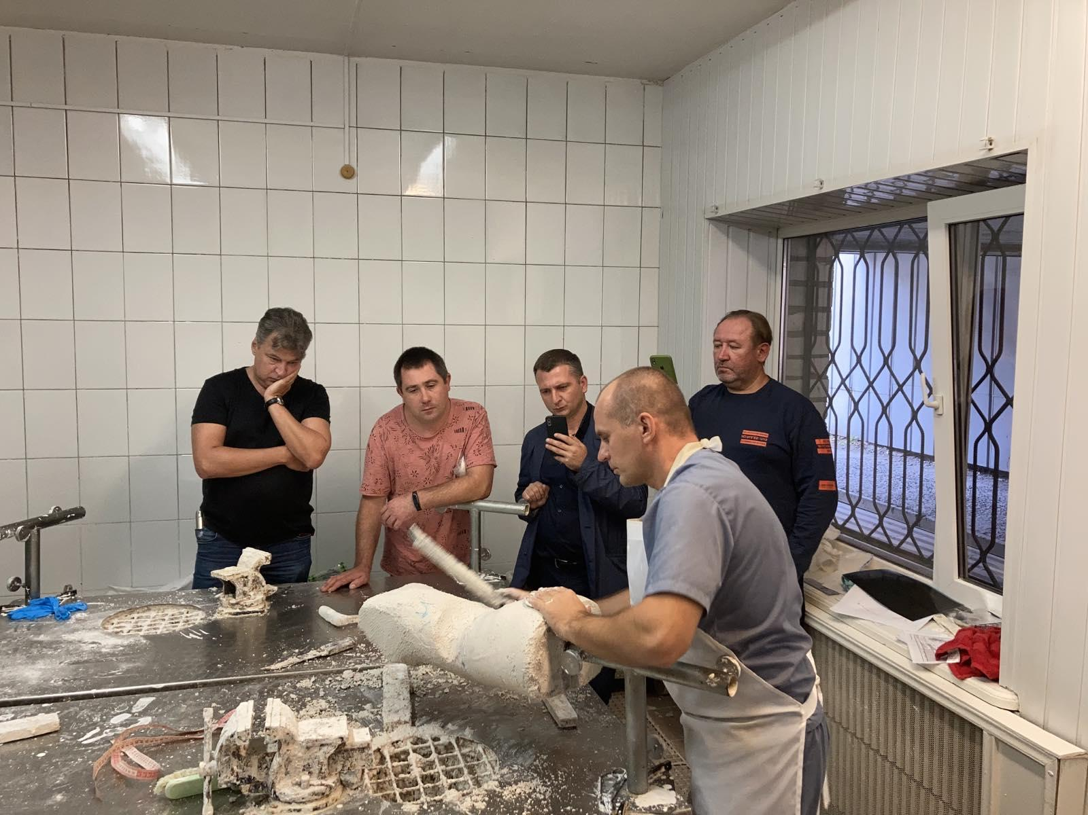

*TO Workshop, Kharkiv, Ukraine – September 2021; Scoliosis Model Rectification*

# Grades Obtained During the Education

|  |  |
| --- | --- |
| **Module I - Lower Extremity Prosthetics** | |
| Anatomy | 8,2 |
| Pathology | 7,5 |
| Biomechanics | 8,3 |
| Workshop Technology | 8,2 |
| Clinical Practice - Module Practical Exam | 7,7 |
| **Module II - Lower Extremity Orthotics** | |
| Anatomy | 7,5 |
| Pathology | 7,8 |
| Biomechanics | 7,3 |
| Workshop Technology | 6,2 |
| Clinical Practice - Module Practical Exam | 6,9 |
| **Module III - Upper Extremity Prosthetics** | |
| Anatomy | 7,7 |
| Pathology | 6,0 |
| Biomechanics | 9,2 |
| Rehabilitation & Disability | 7,1 |
| Clinical Practice - Module Practical Exam | 7,5 |
| **Module IV – Upper Extremity Orthotics / Trunk Orthotics** | |
| Anatomy | 7,8 |
| Pathology | 8,8 |
| Biomechanics | 8,8 |
| Workshop Management | 8,5 |
| Clinical Practice - Module Practical Exam | 7,2 |

**Final Theory Examination Grades**

|  |  |
| --- | --- |
| Anatomy | 8,3 |
| Pathology | 9,2 |
| Biomechanics | 8,2 |
| Workshop Technology | 8,2 |

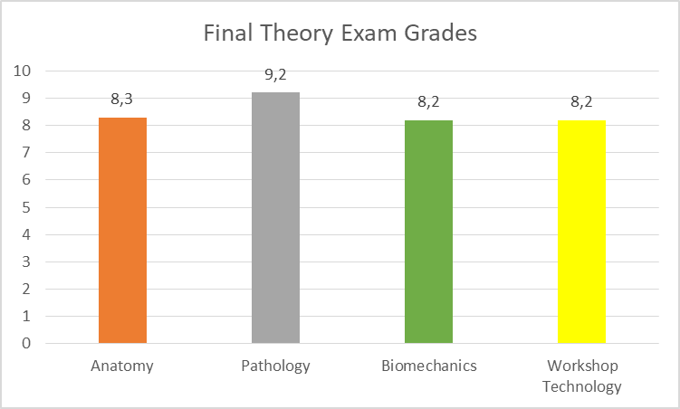

**Final Practical Examination Grades**

|  |  |
| --- | --- |
| Prosthetics | 8,1 |
| Orthotics | 6,8 |
| Average | 7,45 |

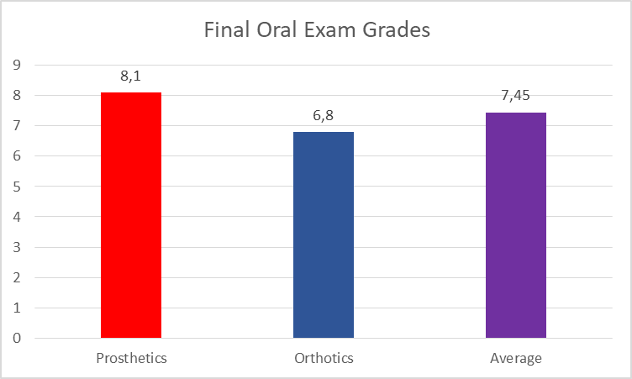

1. To download the presentation press Control and click on the image.
2. To download the presentation press Control and click on the image.
3. To download the presentation press Control and click on the image.
4. To download the presentation press Control and click on the image.